APPLICATION OF THE TAGGED NEUTRON METHOD FOR DIAMONDS DETECTION IN KIMBERLITE

V.M. Bystritsky¹, G.M.Nikitin², Yu.N.Rogov¹, A.B.Sadovsky¹ and M.G.Sapozhnikov¹*

¹Diamant, LLC
4, ac.Baldin Street, Dubna, Russia 141980, sapozhnikov@diamant-sk.ru
² Institute“Yakutniproalmaz”, ALROSA JSC39, Lenina Street, Mirny, Russia, 678174

ABSTRACT

At present kimberlite ore is processed in crushers or grinding rolls with subsequent grinding in wet mills down to a size of 0.2 mm. The basic disadvantage of the standard diamond processing technology is that crushing kimberlite ore can damage the most valuable large diamonds of few carats. Tagged neutron method offers a possible solution to this problem. It allows detecting diamond inside kimberlite ore without its disruption. The results of the tests of the neutron separator prototype carried out at the Lomonosov processing factory of PJSC Severalmaz are discussed. The possibility to detect the diamond in the rock whose size is 10 times larger than the size of the diamond is demonstrated.

KEYWORDS

Tagged neutrons method, dry enrichment of kimberlite, diamonds, neutron generator

INTRODUCTION

At present standard diamond processing technology implies disintegration of kimberlite ore in crushers or grinding rolls down to a size of 0.2 mm. It inevitably leads to high probability that large and most valuable diamonds could be damaged. The fraction of diamonds which lost integrity in the process of ore enrichment could be as large as 35-65% [1].

Tagged neutron method (TNM) [2] offers a possible solution to this problem. It allows detecting diamond inside kimberlite ore without its disruption. The main idea of the TNM is irradiation of an object by fast 14.1 MeV neutrons from binary nuclear reaction

d + ³H →⁴He + n (1)
and detecting (tagging) the ⁴He (α-particle) that accompanies neutron. That gives possibility to determine direction of the neutron momentum. Those tagged neutrons irradiate kimberlite ore under investigation and produce gamma rays via inelastic scattering reactions with nuclei
n + A → n` + A*, A* → γ +A. (2)

Gamma ray spectra from reaction (2) are unique for every chemical element present in kimberlite. Characteristic γ-rays are registered by γ-detectors in coincidence with the signal from the α-detector. Measurement of the time interval between the signals from the α- and γ-detectors allows determining the distance from the neutron source to the point from which the γ-quantum is emitted since the neutron speed is constant and equal to 5 cm/ns. If one uses a position-sensitive α-detector, then knowing the direction of the neutron and distance from tritium target traveled by the neutron until it produced a γ-quantum, it is possible to restore all three spatial coordinates of interaction point. This allows determining spatial distribution of chemical elements concentration in the irradiated sample.

The search for diamonds by the TNM is reduced to detection of excess carbon at a particular point of the kimberlite sample. Large penetrability of fast neutrons makes it possible to examine quite large stones. Thus, rock stones containing diamonds can be identified before the crushing stage and treated by another methods, which significantly decrease the diamonds damages.

Detection of the real diamonds in kimberlite stones of -200 mm size using TNM was demonstrated in [3]. In the following we discuss the results of field tests of the prototype of the TNM neutron separator, which were done on Lomonosov processing factory of PJSC Severalmaz (Arkhangelsk).

MATERIALS AND METHODS

The general scheme of the TNM neutron separator is shown in Fig.1. The kimberlite ore is loaded in feeding hopper and via tray-based feeding system is supplied to the inspection zone of neutron module. In the neutron module the ore is irradiated by the fast 14 MeV neutrons. As the source of fast neutrons a portable neutron generator is used. It is installed under the conveyer belt. Above the belt is the gamma-detector module for detecting the characteristic gamma-radiation induced by the fast neutrons. After analysis of obtained gamma-rays spectra the decision making software produced a signal to move inspected portion of ore either to the tailings or to the concentrate bunkers.

The portable neutron generator ING-27 is designed and produced by the Dukhov All-Russia Research Institute of Automatics, Moscow. It produced a continuous flux of 14.1 MeV neutrons with intensity I=5×10⁷ s⁻¹. The size of the generator is 292×199 ×279 mm, mass is 8.8 kg, and power consumption is 40 Wt.

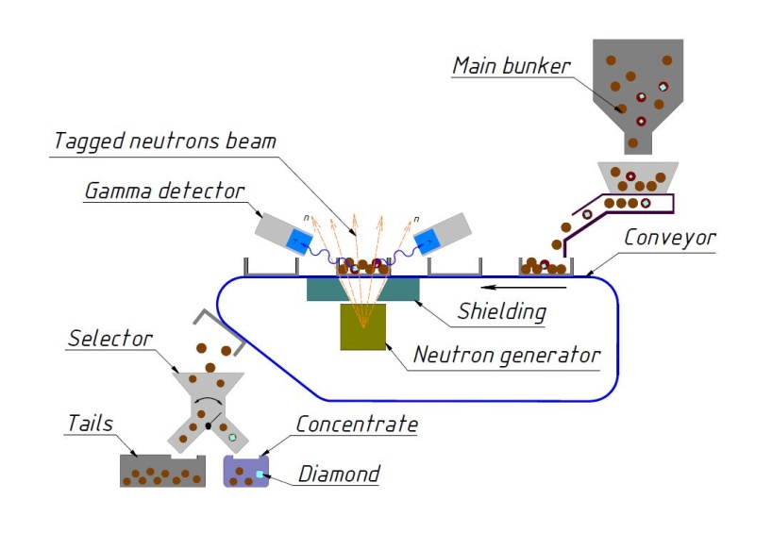
Figure -1. General scheme of the neutron separator.

Uniqueness of the designed generator lies in a 192-pixel built-in silicon based alpha-detector. 192-pixel alpha-detector is a 12×16 matrix of 6×6 mm silicon pixels. The distance between pixel centers is 7 mm, with total sensitive area of alpha-detector of 72×96 mm. The distance from alpha-detector to tritium target is 100 mm. It allows to create 192 tagged neutron beams which irradiated the inspection zone and allows simultaneously determined the carbon concentration in 192 elemental volumes (voxels).

Detection of gamma-rays produced from ore irradiation by fast neutrons is performed by a system of 22 gamma-detectors based on BGO crystals with a diameter of 76 mm and thickness of 65 mm. These detectors have high efficiency of gamma-rays detection within the energy range of interest and low efficiency of background neutrons detection.

Characteristic gamma-rays spectrum of carbon isotope ¹²C is very simple (Fig.2). It features a prominent peak at 4438 keV energy with a single escape peak offset by 511 keV followed by Compton scattering tail. This simple shape of carbon spectrum facilitates detection of carbon signal in gamma-rays spectra obtained by irradiation of kimberlite ore. Since diamonds consist of pure carbon, the technique for diamond detection in kimberlite is reduced to detection of carbon excess in a particular area of the sample.

For testing the setup operation we used different materials: kimberlite ore of -60 mm size from Karpinskogo-1 mine, tailings from X-ray luminescence separators of -30+6 mm size, core samples from Karpinskogo and Arkhangelskaya mines with -150 mm size. We also performed some tests with diamond simulants inserted into the rocks. Diamond simulants are glued cylinders of artificial diamond sand. Simulants of 6, 8, 10, 12 and 14 mm size with typical density of 2,44÷2,48 g/cm³ were prepared.

Figure -2. Energy spectrum of gamma-quanta from irradiation of carbon sample.

RESULTS AND DISCUSSION

The proposed method of diamond detection is based on the search for carbon signal. However, in the real ore the carbon could be present not only in the diamonds but also in different minerals. That is why it is important to estimate the carbon presence in different kimberlite ore.
The energy spectra of the gamma-rays after irradiation of the different samples are shown in Fig.3. We intentionally cut low energy part of spectrum to decrease the data flow and all main visible peaks in Fig.3 are from oxygen, with some admixture from calcium at 3800 keV peak. For the samples from Karpinskogo mine, a small peak of carbon is seen at approximately 4440 keV, while the content of carbon in the samples from Arkhangelskaya mine is smaller.

Figure-3. Energy spectra of gamma-quanta from investigated core samples from different sources shown in red, green and blue.

It is important to note that the small carbon signal of kimberlite is not a unique feature of the Arkhangelsk ore. The same trend is observed in the irradiation of the kimberlite samples from different Letseng mines in Lesotho (see, Fig.4).
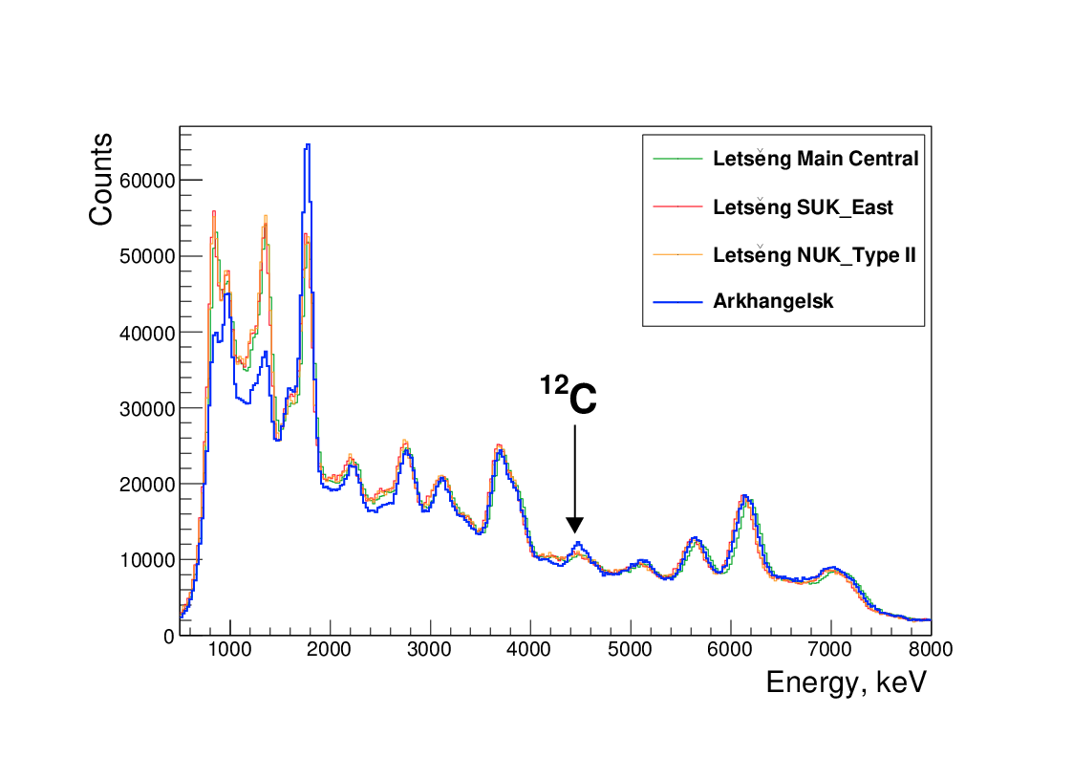

Figure - 4. Energy spectra of kimberlite ore from the Letseng and Arkhangelsk mines.

One can see that the percentage of carbon in the Letseng mine samples are even smaller than in the Arkhangelsk ones. Low carbon content leads to small percentage of the false alarms, when decision making software treated pure ore signal like a diamond one.

Fig.5-a shows gamma-spectra from irradiation of 8 mm diamond imitator inserted in the kimberlite ore sample of 50 mm size and surrounded by ore samples of the same size. Red points with error bars represent gamma-ray spectrum for tagged beam irradiating voxel with diamond imitator, while black histogram represent spectrum of ore sample averaged over all voxels of the inspection zone. The local carbon signal excess is a clear indication of presence of diamond imitator in the selected voxel. Fig.5-b shows gamma-spectra from the same measurement, but for a voxel next to the voxel with diamond imitator, it’s obvious, that there is no carbon excess present.

a) b)
Figure-5. Gamma-ray spectrum of the voxel with 8 mm diamond imitator in 50 mm kimberlite ore (a). Gamma-ray spectrum of the voxel of 50 mm kimberlite ore without diamond imitator (b). Red points with error bars represent gamma-ray spectrum from voxel with diamond imitator. Black histogram represents spectrum of ore sample averaged over all voxels of the inspected zone.

One of the advantages of TNM is high penetration ability of 14 MeV neutrons and high penetration ability of resulting 4.4 MeV gamma-rays. This allows investigating relatively thick ore samples. The largest analyzed rock had size of 160×90×90 mm with inserted 14 mm diamond imitator. Corresponding spectrum is shown in Fig.6. One can see, that even for 10:1 ore to diamond size ratio a clear excess in the carbon peak region is visible.
Figure-6. Gamma-ray spectrum of voxel with 14 mm diamond imitator in 160×90×90 mm kimberlite ore rock. Red points with error bars represent gamma-ray spectrum from voxel with diamond imitator. Black histogram represents spectrum of ore sample averaged over all voxels of the inspected zone.

Radiation control is a crucial part of the TNM neutron separator. Measurements of radiation environment during neutron generator switching on gave the value of 0.11 μSv/h at operator location. Induced activity of ore samples after irradiation was 0.17 μSv/h. The natural radioactive background at operation location was 0.09-0.11 μSv/h.

Special investigation was done to test if irradiation of diamonds in the neutron separator could lead to a change in their properties, which may be considered as an attempt to refine the diamond [4]. A collection of 90 diamonds was selected from the current production of diamonds from the Mir, Aikhal and Udachnaya pipes of the JSC ALROSA, which was irradiated with beams of 14.1 MeV neutrons. Optical-spectroscopic studies of the crystals were performed before and after the irradiation. It was concluded that irradiation by fast neutrons in the typical conditions of TNM separator, were the integral radiation energy densities could not be more than 2.32 × 10¹² eV / cm², cause no changes in either the visual properties of diamonds, the IR absorption spectra, or the photoluminescence spectra [4].

CONCLUSIONS

Field testing of prototype of neutron separator used TNM was done on Lomonosov mine of PJSC Severalmaz. In total it was processed 68.1 tons of XRL tailings, 4.5 tons of kimberlite ore and performed 669 tests with diamond imitators. The throughput of the prototype was 1040 kg/hour for ore size 50 mm. The concentrate yield (a fraction of ore with positive response of the detection procedure) was 5%. The detection probability of 8 mm diamond imitators hidden in the -50+20 mm ore was 98%. The largest operable ore size was 150 mm. It was demonstrated that it is possible to detect the diamond in the rock whose size was 10 times larger than the size of the diamond.

ACKNOWLEDGEMENTS

We would like to express our gratitude to Skolkovo Foundation and to S.A.Zhurba for financial support in prototype construction and testing, to PJSC Severalmaz administration represented by A.V.Pismenny, I.I.Ivanov, V.V.Kolenchenko, A.V.Yamov for help in organizing of the tests. We would like to thanks Gem Diamonds CEO C.Elphick for providing ore samples from Letseng mine.

REFERENCES

- V.A.Karnatsky et al, 2012. Increasing of JSC Alrosa production due to improvements in diamond processing technology, Mineral processing, N6, 13-17.
- V.Valkovic, 2016. 14 MeV Neutrons: Physics and Applications, CRC Press, Boca Raton.
- V.Alexakhin et al., 2015. Detection of Diamonds in Kimberlite by the Tagged Neutron Method, Nuclear Instruments and Methods A785, 9-13.
- O.Kovalchuk et al, 2017, Irradiation of diamonds by fast tagged neutrons. JINR (Dubna) preprint, P-14-2017-54.

